Fall Newsletter September 2017

ST. MARTIN’S CHURCH NEWS

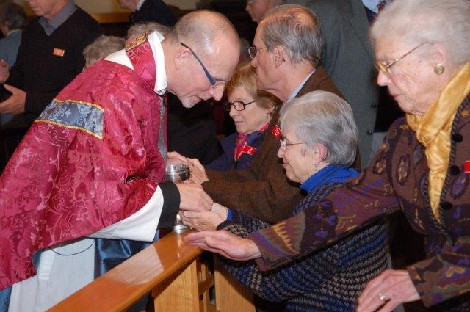
The Rector’s Message for Homecoming Sunday

Summer is fast ending. I do hope most of you found time for recreation and change of scene or at least a slower pace. We enter the season memorialized by Keats in his Ode to Autumn as the season of mists and mellow fruitfulness. Labor Day marks the transition point from the ease
of the summer schedule rapidly ramping into the a new program year. As we peer into the mists of autumn, what might we expect? This message accompanies the autumn calendar of events, so please pin this up on your fridge door. On Homecoming Sunday, in lieu of a sermon, we will hear in Church from the spokespersons of our significant ministry groups, followed by ministry tables at coffee hour. This fall we launch a brand new initiative of the East Side Choir School, our new music outreach ministry to children in the wider community. On September 19th, we will hold the first of monthly healing services.

The major initiative for the fall will be our annual renewal or spiritual inventory of tender competence. Between October 15th and November 5th, we will hold Adult Forum presentations and discussions on the economics of happiness, which also happens to be the title of Mark Anielski’s groundbreaking book on building genuine wealth. More on that in due course.

November and December are also packed months with: Ingathering Sunday on the morning of November 12th with St Martin’s Day Choral Evensong and Feast in the afternoon and evening; Interfaith Thanksgiving Service at Temple Beth-El November 21st; December 2nd is our Advent celebration - this year a dramatic performance by the Rev. Joseph Morris of Mark’s Gospel - check out http://www.gospelofmark.us/ followed by an afternoon tea reception; and on December 17th we will host our second annual Carol Sing.

We remain a magnetic community, reconfiguring ourselves for those who are not yet our members. Through your involvement in the coming year, help us to continue to punch above our weight in the service of the Gospel message of hope and courage to a world in transition.
Mark+
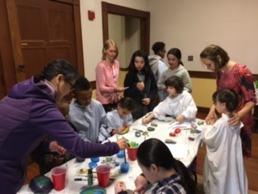
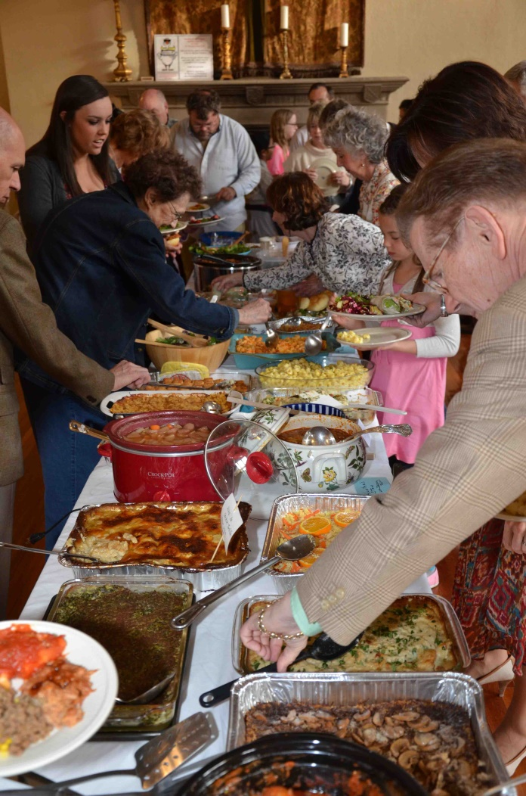
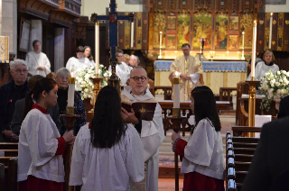

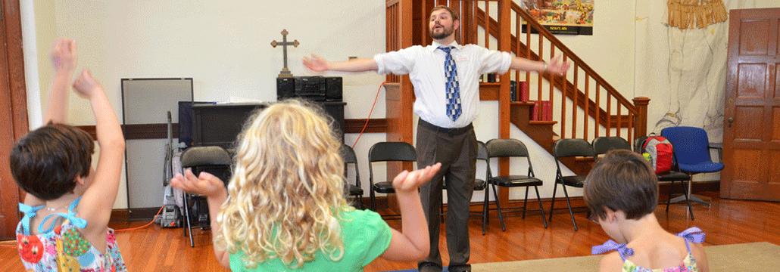
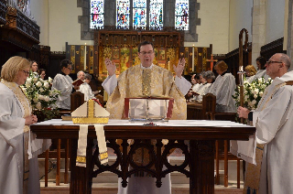
Mark your Calendars!
NOVEMBER
Saturday, November 4
Knitting Ministry 12:30pm
Sunday, November 5
All Saints’ Sunday
Daylight Savings Time ends
(move your clocks back)
Youth Skip Church Breakfast 9:30am in the kitchen
Saturday, November 11
Memorial Garden Clean-up 10am
Sunday, November 12
St. Martin’s Day
Stewardship Sunday
Evensong 4:30pm
Potluck Supper 5:30pm
Tuesday, November 14
Women Spirituality Group at 6pm
Sunday, November 19
Children/Youth sing during the 9:30am service
Advent Outreach Project Launch
Tuesday, November 21
Healing Service at 5:30pm
Interfaith Thanksgiving Service at Temple Beth-El
at 7pm
Thursday, November 23
Community Thanksgiving Dinner 1pm

SEPTEMBER
Wednesday, September 6
East Side Choir School first rehearsal 6:30pm
Thursday, September 7
Weekly Meditation resumes 5:30pm
Adult Choir rehearsal 7:30pm
Sunday, September 10 – Homecoming Sunday!
8am & 9:30am services resume
Nursery at 9:15am
10:30am Ministry Fair
Coffee Hour hosted by the Vestry

Wednesday, September 13
The Thrifty Goose reopens 10am-2pm
Sunday, September 17
Church School begins 9:15am
Adult Forum 10:45am
Tuesday, September 19
Healing Service at 5:30pm
Friday, September 22
TGIF (Thank Goodness it’s Friday) 6pm
Mingle with friends, new and old, over hors d’oeuvres
Sunday, September 24
Children/Youth sing during the 9:30am service
Tuesday, September 26
Women’s Spirituality Group 6pm

DECEMBER
Saturday, December 2
Mark’s Gospel Live with the Rev. Joseph Morris 2pm
followed by Advent Tea
Sunday, December 3
Youth Skip Church Breakfast
Visit from St. Nicholas
Advent Festival with Advent wreath making
Pageant Sign-ups
Tuesday, December 5
Women’s Spirituality Group at 6pm
Sunday, December 17
Community Carol Sing 4:00pm
Tuesday, December 19
Healing Service at 5:30pm
Thursday, December 21
‘Blue Christmas’ Service at 5:30pm
Sunday, December 24 – Christmas Eve
8:00am Spoken Eucharist
4:00pm with Brass and Pageant
9:00pm with Strings and Choir
Monday, December 25 – Christmas Day
Eucharist with Carols 9:30am

OCTOBER
Sunday, October 1
Youth Skip Church Breakfast 9:30am in the kitchen
Youth/Parent meeting 10:45am in the Stearns Room
Blessing of the Animals 4pm
Friday, October 6
American Guild of Organists Evensong 6:30pm
Saturday, October 7
“Voices that Matter” Workshop with Ray McGinnis 9:30am-noon
Knitting Ministry at 12:30p
Sunday, October 15
Children/Youth sing during the 9:30am service
Tuesday, October 17
Healing Service at 5:30pm
Tuesday, October 24
Women’s Spirituality Group 6pm

St. Martin’s Church 50 Orchard Avenue Providence, RI 02906
401-751-2141 www.stmartinsprov.org

